Data Analytics with Tableau Project Documentation

# 1. Introduction

Project Title:  
Visualizing Housing Market Trends: An Analysis of Sale Prices and Features using Tableau

Team Member:  
CHEREDDY VENKATA VINOD KUMAR REDDY

# 2. Project Overview

Purpose:  
This project analyzes housing market data to understand how features such as renovation status, house age, and structural factors impact sale prices. The aim is to provide stakeholders with actionable visual insights.

Features:  
• Interactive Tableau dashboard  
• Sale price trends by renovation  
• House age vs. structure analysis  
• KPIs for total sales and average price  
• Web deployment using Flask

# 3. Architecture

Frontend:  
HTML + CSS (index.html, other pages) — Embeds Tableau dashboards and story views

Backend:  
Python Flask (app.py) — Serves HTML files locally

Data Source:  
Static dataset (dataset_house.csv) used for Tableau visualization

# 4. Setup Instructions

Prerequisites:  
• Python 3.x  
• Flask (pip install flask)  
• Tableau Public account  
• Web browser

Installation Steps:  
1. Clone or download the project folder  
2. Install Flask: pip install flask  
3. Run the server: python app.py  
4. Open your browser and go to http://localhost:5000

# 5. Folder Structure

housing-market-trends/  
├── app.py # Flask backend  
├── templates/  
│ ├── index.html # Home page  
│ ├── about.html # About the project  
│ ├── dashboard.html # Tableau Dashboard embed  
│ └── story.html # Tableau Story embed  
├── static/  
│ └── style.css # Styling for HTML pages  
├── dataset_house.csv # Dataset used for Tableau  
├── README.md # Project overview

# 6. Running the Application

Frontend: Hosted locally with Flask  
Backend: Flask runs the server via python app.py  
Access: Navigate to http://localhost:5000 in your browser

# 7. API Documentation

No external or internal APIs used. All visualizations are served via Tableau Public embedded links.

# 8. Authentication

Not applicable. Public-facing dashboard requires no login or secure access.

# 9. User Interface

• Navigation bar with links to Home, About, Dashboard, and Story  
• “Get Started” button on home page  
• Tableau dashboards embedded in custom layout  
• Responsive visuals with clean, modern design

# 10. Testing

• Manual browser-based testing  
• Verified functionality on Chrome and Edge  
• Checked embedded Tableau responsiveness and performance

# 11. Screenshots or Demo

Dashboard Screenshot:

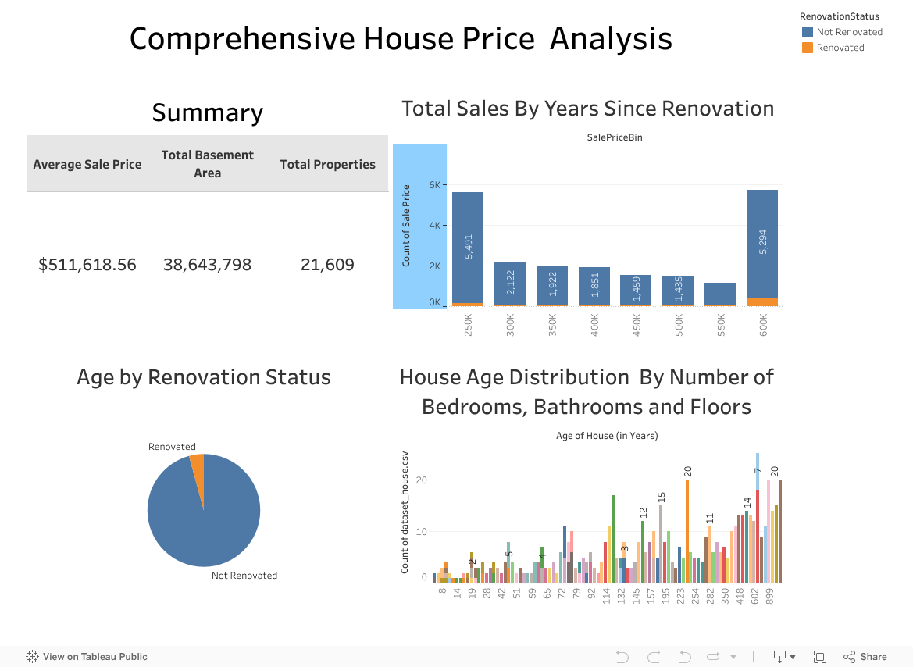

Live Story Link:

[tableau_work111 | Tableau Public](https://public.tableau.com/app/profile/vinod.chereddy/viz/tableau_work111/Dashboard1?publish=yes)

# 12. Known Issues

• Tableau dashboards may take time to load on slow internet  
• Not fully optimized for mobile devices  
• Public Tableau link must remain published

# 13. Future Enhancements

• Add dropdown filters or interactive controls  
• Integrate live housing data sources  
• Add user authentication for dashboard management  
• Enable custom queries with database backend